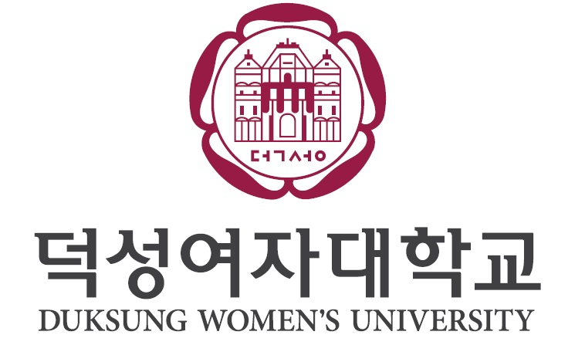
application for Duksung EXCHANGE PROGRAM
All information must be typed.

1. PERSONAL DATA

Full Name

Please attach a recent photo
First name Middle name Last/family name
Date of birth Gender M F
Day Month Year
Enter name & date of birth exactly as it appears on your passport.

Country of Birth Country of Citizenship
E-mail Address
(Please write your frequently used email, since we will to contact you via email.)
Permanent Home Address
Number and Street

City State Country Postal Code
Home Phone Cell Phone

Predominant language spoken in your home
Indicate your fluency of the foreign languages listed below.
KOREAN fluent good a little none
(Please state any specific test scores you have: TOPIK )
ENGLISH fluent good a little none
OTHERS ( ) fluent good a little none

Dietary Preferences none Vegetarian Muslim Other ( )
Medical Conditions
Allergies
Other remarks about your health condition:
2. EDUCATIONAL DATA
Name of Institution of Current Enrollment:
Academic Field:
Major Name of Department & College
Academic Level: Freshman Sophomore Junior Senior Graduate Student

Educational Background (from high school level)
Name of Institution | Country | Duration(MDY-MDY)
Possible area(s) of academic major(s) to study at Duksung Women’s University

Intended Semester(s) to Study: 1 semester / full academic year (please circle)
Year and Semester of Entrance: Fall / Spring (please circle)

3. EXCHANGE COORDINATOR INFORMATION
Exchange Coordinator Contact Information (at your home institution)
Name Position Department
Mailing Address
(Your Certification of Admission will be sent to your home institution)
Telephone Email

4. DORMITORY
Residential Preference:
※Dormitory choices may not be guaranteed upon availability.
※Dormitory fees may change according to personal residing schedule.
※First come, first served. Since the space is limited, I recommend to apply as soon as you can.
Duksung International Dormitory (Single Room with bathroom)
Duksung International Dormitory (Triple Room with bathroom)
Male Students: Duksung International Dormitory (Double Room)
I will provide my own housing

5. KOREAN LANGUAGE CLASS
Duksung Global Education Center : Extra Korean Language Course (Mon-Fri 09:00 ~ 13:00 or 14:00 ~ 18:00 / 10 weeks)
50% Discounted Tuition Fee: KRW 750,000 (For more detailed information, please refer to the separate attachment.)
(The tuition fee is subject to increase in future semesters. Please apply only after careful consideration, as cancellations may be difficult.)
I will take additional Korean Language Course (50% off for 10 weeks)
I prefer not taking additional language course

6. FINANCIAL DATA
Indicate the person or organization that will be responsible for your expenses during your study period at Duksung Women’s University.
Name Relationship
Address
Telephone Email

Approximate Amount of Support during the semester(s) US$
NOTE: The Korean Consulate may ask you to submit the sponsor’s ‘Certificate of Deposit Balance’ along with other financial documents to prove the sponsor’s financial abilities.

The Sponsor’s Certification “I guarantee that I will be responsible for the applicant’s all the expenses for the duration of the exchange program.”

Name Signature Date

7. SUBMISSION DOCUMENT LIST
I have included the followings with the application form.
‘Certificate of Enrollment’ - in English (issued by home university)
※Certificate of Enrollment must obtain Apostille or Consular Confirmation
‘Academic Transcript’ - in English
‘Letter of Recommendation’ from a professor in the Dept. focusing on academic performance – in English or Korean
A ‘Study Plan’ (personal essay, 1 ~ 1.5p) – in English or Korean
A copy of passport (the page with the photograph)
Bank Balance Certificate – in English(more than 7,500,000KRW for a semester / 15,000,000KRW for 2 semesters)
All the documents should be turned in via e-mail (inbound@duksung.ac.kr) first by international office of home university, and the original document needs to be sent to Duksung International Affairs office by post.

By signing the below, certify that all the information in my application is true and correctly written and that I agree to the usage of my personal information for Duksung Women’s University to process the admission and to enroll in the exchange program and other related matters

Name Signature Date

Note: For Spring(March) Semester document submission deadline: Nov. 10th
For Fall(September) Semester document submission deadline: May 10th

International Affairs, Duksung Women’s University
381 Uicheon-ro, Dobong-gu, Seoul 01370, Korea
Tel) +82-2-901-4606 Fax) +82-2-901-0589 Email) inbound@duksung.ac.kr
http://www.duksung.ac.kr

